Lab 3
UPDATE AND DELETE RECORDS

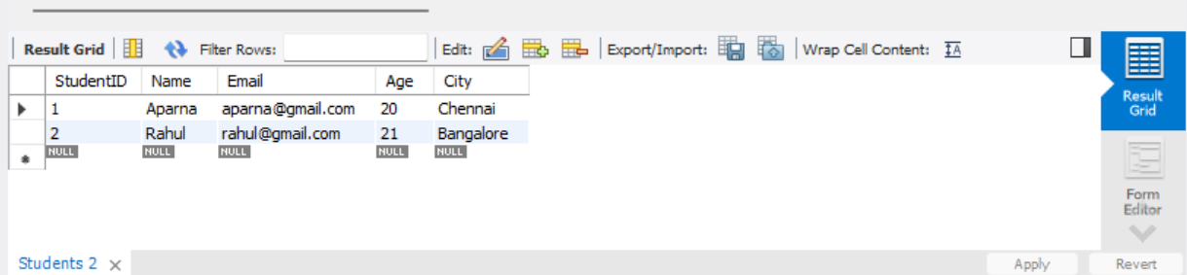

The INSERT command is used to insert new records into the Students table. Here, two student records, Aparna and Rahul, have been inserted with their StudentID, Name, Email, Age, and City.
Result: Thus, two records were successfully inserted into the Students table.

